**Detecting Parkinson’s Disease Using Machine Learning**

More than 10 million people are living with Parkinson’s Disease worldwide, according to the Parkinson’s Foundation. While Parkinson’s cannot be cured, early detection along with proper medication can significantly improve symptoms and quality of life.

The researchers found that the drawing speed was slower and the pen pressure is lower among Parkinson’s patients. One of the indications of Parkinson’s is tremors and rigidity in the muscles, making it difficult to draw smooth spirals and waves. It is possible to detect Parkinson’s disease using the drawings alone instead of measuring the speed and pressure of the pen on paper. Our goal is to quantify the visual appearance(using HOG method) of these drawings and then train a machine learning model to classify them. In this project, We are using, Histogram of Oriented Gradients (HOG) image descriptor along with a Random Forest classifier to automatically detect Parkinson’s disease in hand-drawn images of spirals and waves.

**Technical Architecture:**

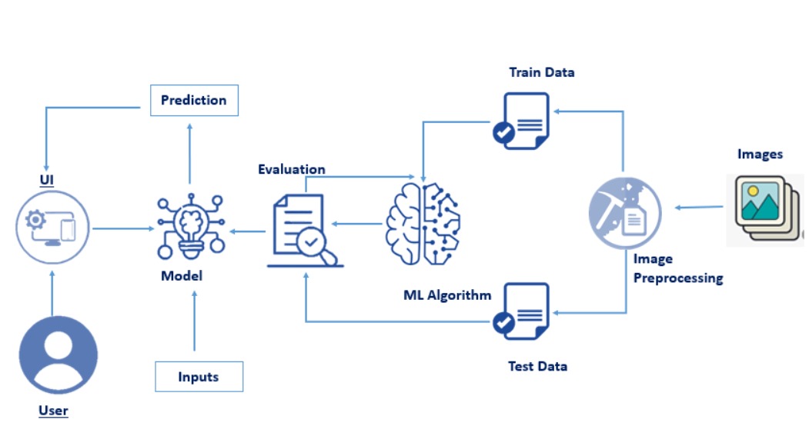

### Project Objectives

**By the end of this project:**

* You’ll be able to understand the problem to classify if it is a regression or a classification kind of problem.
* You will be able to know how to pre-process the image by using different data pre-processing techniques.
* you will be able to learn how to use OpenCV and machine learning to automatically detect Parkinson’s disease in hand-drawn images of spirals and waves
* You will be able to know how to find the accuracy of the model.
* You will be able to build web applications using the Flask framework.

### Project Flow

* User interacts with the UI (User Interface) to upload the image as input
* The uploaded image is analyzed by the model which is integrated
* Once the model analyzes the uploaded image, the prediction is showcased on the UI and OpenCV window

**To accomplish this, we have to complete all the activities and tasks listed below**

* Data Collection
  + Collect the dataset or Create the dataset
* Image Preprocessing.
* Importing the required libraries
* Loading Train data and Test data
* Quantifying images
* Label Encoding
* Model Building
  + Training the model
  + Testing the model
  + Model Evaluation
  + Saving the model
* Application Building
  + Create an HTML file
  + Build Python Code

### Pre-Requisites

#### In order to develop this project we need to install the following software/packages:

**Anaconda Navigator :**

Anaconda Navigator is a free and open-source distribution of the Python and R programming languages for data science and machine learning related applications. It can be installed on Windows, Linux, and macOS. Conda is an open-source, cross-platform, package management system. Anaconda comes with so very nice tools like JupyterLab, Jupyter Notebook, QtConsole, Spyder, Glueviz, Orange, Rstudio, Visual Studio Code. For this project, we will be using Jupyter notebook and Spyder

To install Anaconda navigator and to know how to use Jupyter Notebook & Spyder using Anaconda watch the video

<https://youtu.be/5mDYijMfSzs>

**To build Machine learning models you must require the following packages**

* **Numpy:**
* It is an open-source numerical Python library. It contains a multidimensional array and matrix data structures and can be used to perform mathematical operations
* **Scikit-learn:**
* It is a free machine learning library for Python. It features various algorithms like support vector machine, random forests, and k-nearest neighbours, and it also supports Python numerical and scientific libraries like NumPy and SciPy
* **Scikit-image**
* Scikit-image or skimage,  is an open-source Python package designed for image preprocessing.

* **Install imutils**
* Imutils are a series of convenience functions to make basic image processing functions such as translation, rotation, resizing, and displaying Matplotlib images easier with OpenCV
* Open anaconda prompt and type this command

**“pip install imutils”**

* **OpenCV**
* [OpenCV](https://en.wikipedia.org/wiki/OpenCV) is a library of programming functions mainly aimed at real-time computer vision. Here, OpenCV is used to capture frames by accessing the webcam in real-time.
* Open anaconda prompt and type this command

**“pip install opencv-contrib-python”**

* **Flask:**

Web framework used for building Web applications

If you are using anaconda navigator, follow below steps to download required packages:

* Open anaconda prompt.
* Type **“pip install numpy”**and click enter.
* Type **“pip install scikit-image”** and click enter.
* Type **“pip install imutils”** and click enter.
* Type**“pip install scikit-learn”**and click enter.
* Type **“pip install opencv-contrib-python”**and click enter.
* Type **“pip install Flask”** and click enter.

<https://youtu.be/akj3_wTploU>

If you are using Pycharm IDE, you can install the packages through the command prompt and follow the same syntax as above.

### Prior Knowledge

#### One should have knowledge of the following Concepts

Please refer to the videos below to gain required knowledge to complete the project.

<https://youtu.be/kE5QZ8G_78c>

<https://youtu.be/6za9_mh3uTE>

<https://youtu.be/nxFG5xdpDto>

<https://youtu.be/4ESLTAd3IOM>

<https://youtu.be/lj4I_CvBnt0>

### Project Structure

Let us introduce you to the main project folder downloaded by you in prerequisites.

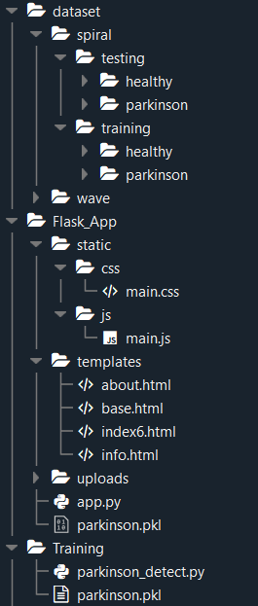

* Training folder contains:
* Parkinson_detect.py
* model file “parkinson.pkl”
* Flask App folder contains:
* static folder with the style sheets and the image required
* templates folder with the HTML pages
* app.py, a python script (Flask file) for server side computing.

### Data Collection

ML depends heavily on data, without data, it is impossible for a machine to learn. It is the most crucial aspect that makes algorithm training possible. In Machine Learning projects, we need a training data set. It is the actual data set used to train the model for performing various actions.

### Download The Dataset

You can collect datasets from different open sources like **kaggle.com, data.gov, UCI machine learning** repository etc.

The dataset is first broken down into spiral and wave. Each folder is further split into testing and training. Finally, our images reside in healthy or Parkinson folders.

The healthy folder consists of geometric images drawn by a healthy person.

The Parkinson folder consists of geometric images drawn by Parkinson person.

Please refer to the link given below to download the data set 



..

..

<https://drive.google.com/drive/folders/1Y3m9E98m33v6L9AqWWgHlzvMA_TsyQBi?usp=sharing>

**Image Pre-Processing**

In general, we prefer to use Deep learning and Convolution Neural Network for image data. In CNN we use data augmentation to pre-process the data. But as our data is very sensitive, improper use of data augmentation may lead to predicting a healthy person’s drawing look like Parkinson’s patient(drawing).

Therefore, applying computer vision to this problem is an appropriate choice.

### Importing The Necessary Libraries

The first step is usually importing the libraries that will be needed in the program.

The required libraries to be imported to  Python script are:

**OpenCV:**

[OpenCV](https://en.wikipedia.org/wiki/OpenCV) is a library of programming functions mainly aimed at real-time computer vision. Here, OpenCV is used for resizing. Rescaling, thresholding the image.

**Imutils:**

Imutils package has a series of convenience functions to make basic image processing functions such as translation, rotation, resizing, and displaying Matplotlib images and video frames easier with OpenCV.

We will build_montages  for visualization. Our paths import will help us to extract the file paths to each of the images in our dataset.

**sklearn.metrics**:

The module implements several loss, score, and utility functions to measure classification performance.

**sklearn.preprocessing**:

This package provides several common utility functions and transformer classes to change raw feature vectors into a representation that is more suitable for the downstream estimators.

**Sklearn.ensemble**

This package contains RandomForestClassifier and many more inbuilt algorithms.

**Scikit-image**

Scikit-image, or skimage,  is an open-source Python package designed for image preprocessing.

Histogram of Oriented Gradients (HOG) will come from the feature import of scikit-image.

**Pickle:**

Python pickle module is used for serializing and de-serializing python object structures. The process to converts any kind of python objects (list, dict, etc.) into byte streams.

Now we will open spyder from the start menu.

All the above modules can be imported into our program using the below code

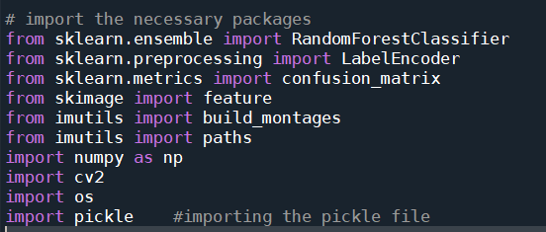

Once we have imported the packages we start loading the dataset.

**Loading Train Data And Test Data**

After importing the necessary libraries, the next step is to define the training path and testing path.

Our dataset contains both hand-drawn spiral and wave patterns. Here we are taking spiral patterns into consideration and training the model.

We split the data into train and test. Using the training dataset we train the model and the testing dataset is used to predict the results.

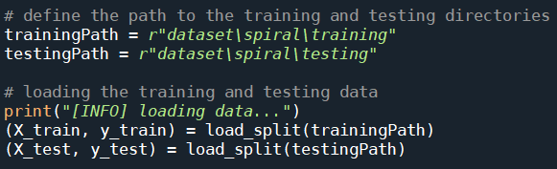

**Note:** Can try the same with wave pattern dataset

**load_split()**

The load_split  function accepts a dataset path and returns all feature data and associated class labels.

* From there we grab input image paths by making use of imutils .
* Initialising data and labels lists.
* loop over all image paths which we have grabbed in the previous step.
* Each label is extracted from the os.path.split() method in Python which is used to split the pathname into a pair head and tail. Here, the tail is the last pathname component and the head is everything leading up to that.
* Each image is loaded and preprocessed.
* Read the input image
  + **Imread()** a pre-defined method is used to read the input image
* **Convert image to grayscale**
  + cv2.cvtColor(frame, flag): is used for color conversion.
  + cv2.COLOR_BGR2GRAY: The flag is used to convert the coloured image to grayscale.
  + we convert the image to grayscale to reduce the processing time
* **Resizing the image**
  + resize it to 200x200 pixels,
* **Threshold image**
  + The thresholding step segments the drawing from the input image, making the drawing appear as a white foreground on a black background.
  + Please refer to this [link](https://opencv-python-tutroals.readthedocs.io/en/latest/py_tutorials/py_imgproc/py_thresholding/py_thresholding.html)for more information on image thresholding concept.
  + Features are extracted via our quantify_image  function.
  + The features and label are appended to the data and labels lists respectively.
  + Finally, data and labels are converted to NumPy arrays and returned conveniently in a tuple.

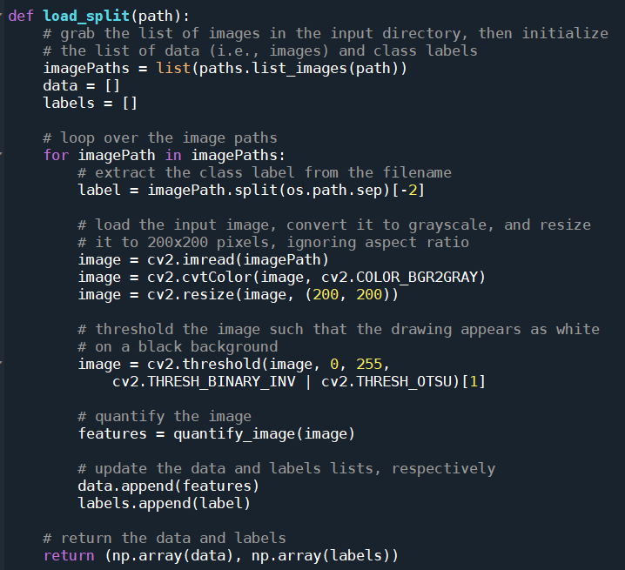

**Quantifying Images**

We will extract features from each input image with the quantify_image  function.

HOG is a structural descriptor that will capture and quantify changes in local gradient in the input image. HOG will naturally be able to quantify how the directions of a both spirals and waves change.

It will be able to capture if these drawings have more of a “shake” to them, as we expect from a Parkinson’s patient.

The most important parameters for the HOG descriptor are the **orientations**,  **pixels_per_cell,** and the  **cells_per_block**. These three parameters (along with the size of the input image) effectively control the dimensionality of the resulting feature vector.

The resulting features are a 12,996-dim feature vector (list of numbers) quantifying the wave or spiral. We’ll train a Random Forest classifier on top of the features from all images in the dataset.

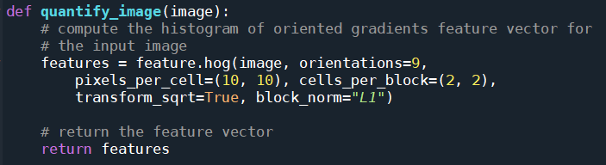

### Label Encoding

**Label Encoding** is a process by which categorical variables are converted into a form that could be provided to ML algorithms to do a better job in prediction. We apply  Encoding in order to convert the values into 0’s and 1’s.

As we have observed that we have labels in our dataset. We need to convert them into binary values by using Label encoding. 0:healthy,1:Parkinson

Create an object **le** and fit the **y_train, y_test**using **fit_transform.**

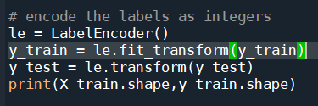



Detailing 2 important approaches in Machine Learning to convert catego..

Detailing 2 important approaches in Machine Learning to convert categorical data into numerical data..

<https://towardsdatascience.com/categorical-encoding-using-label-encoding-and-one-hot-encoder-911ef77fb5bd>

### Model Building

There are several Machine learning algorithms to be used depending on the data you are going to process such as images, sound, text, and numerical values. The algorithms can be chosen according to the objective. As the dataset which we are using is a classification so you can use the following algorithms

* Random Forest Classification
* Decision Tree Classification

You will need to train the datasets to run smoothly and see an incremental improvement in the prediction rate.

**Training The Model**

* Once after splitting the data into train and test, the data should be fed to an algorithm to build a model.
* There are several Machine learning algorithms to be used depending on the data you are going to process such as images, sound, text, and numerical values. The algorithms that you can choose according to the objective that you might have it may be Classification algorithms are Regression algorithms.

1.Logistic Regression

2.Decision Tree Classifier

3.Random Forest Classifier

4.KNN

**Random Forest classifier**

Initialize our **Random Forest classifier** and train the model using a number of estimators as 100

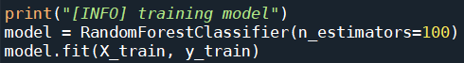

**Testing The Model**

After training the model, the model should be tested by using the test data which is been separated while splitting the data for checking the functionality of the model.

Here we are selecting 25 images from the test data and initialize the output images for montage

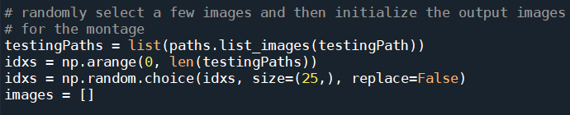

we’re going to create a montage so that we can share our work visually

* First, we randomly sample images from our testing set

* Our images  list will hold each spiral image along with annotations added via OpenCV drawing functions .

* We proceed to loop over the random image indices.

* Inside the loop, each image is processed in the same manner as during training(convert to gray scale, resize, threshold) .

* From there we’ll automatically classify the image using our new HOG + Random Forest based classifier and add color-coded annotations

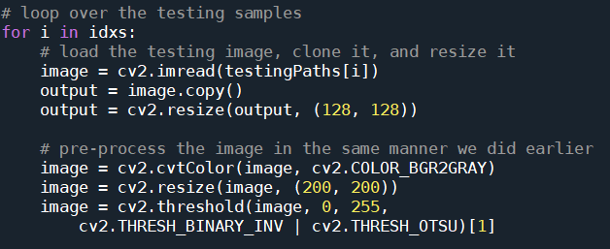

* Each image is quantified with HOG features.

* Then the image is classified bypassing those features to model.predict .

* The class label is colored <strong>green</strong> for “healthy”  and <strong>red</strong> otherwise .The label  is drawn in the top left corner of the image using cv2.putText function .

* Each output  image is then appended to an images  list so that we can develop a montage

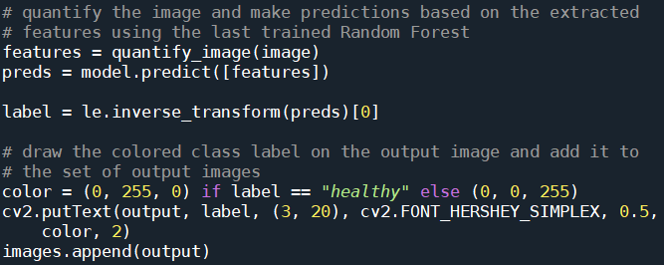

* The montage is then displayed until a key is pressed

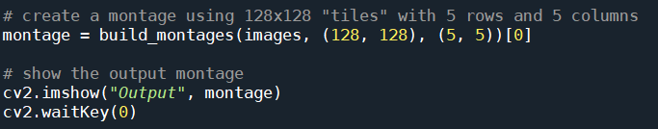

The **cv2.imshow()**function always takes two more functions to load and close the image. **cv2.waitKey()** function, you can provide any value to close the image and continue with further lines of code.

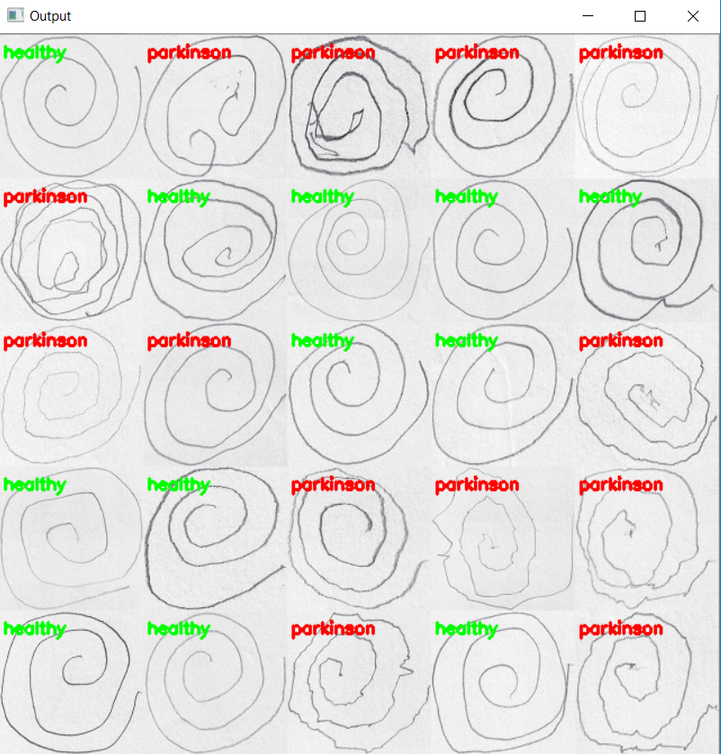

From the above montage, we can clearly differentiate between the geometric patterns drawn by healthy and Parkinson patient.

**Model Evaluation**

Evaluation is a process during the development of the model to check whether the model is the best fit for the given problem and corresponding data.

**Classification Evaluation Metrics:**

These model evaluation techniques are used to find out the accuracy of models built in the classification type of machine learning models. We have three types of evaluation methods.

* Accuracy_score
* Confusion matrix
* Roc- Auc Curve

**Confusion Matrix**

It is a matrix representation of the results of any binary testing.

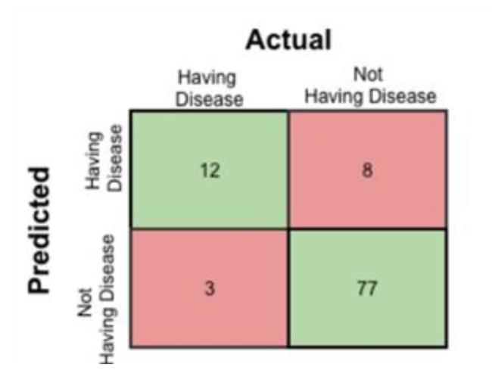

       Fig: Confusion Matrix of prediction of a disease

1. True Positive: 12 (You have predicted the positive case correctly!)
2. True Negative: 77 (You have predicted negative case correctly!)
3. False Positive: 8 (You have predicted these people as having disease, but in actual they do not have.)
4. False Negative: 3 (Wrong predictions )

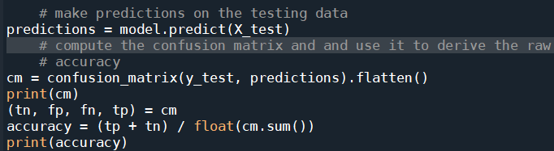

We can use the **predict** method on the model and pass **X_test** as a parameter to get the output as predictions.

The output of the confusion matrix and accuracy are as follows.

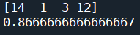

### Save The Model

After building the model we have to save the model.

Pickle in Python is primarily used in serializing and de-serializing a Python object structure. In other words, it's the process of converting a Python object into a byte stream to store it in a file/database, maintain program state across sessions or transport data over the network. wb indicates write method and rd indicates the read method.

This is done by the below code



**Application Building**

In this section, we will be building a web application that is integrated to the model we build. A UI is provided for the users where he has to enter the values for predictions. The values which are entered will be given to the saved model and prediction is showcased on the UI.

This section has the following tasks

* Building HTML Pages
* Building server-side script

### Building HTML Pages

For this project create four HTML files namely

* about.html
* base.html
* index6.html
* info.html

and save them in templates folder

download the HTML files from the given link in the prerequisites section.

Let’s see how our home.html page looks like:

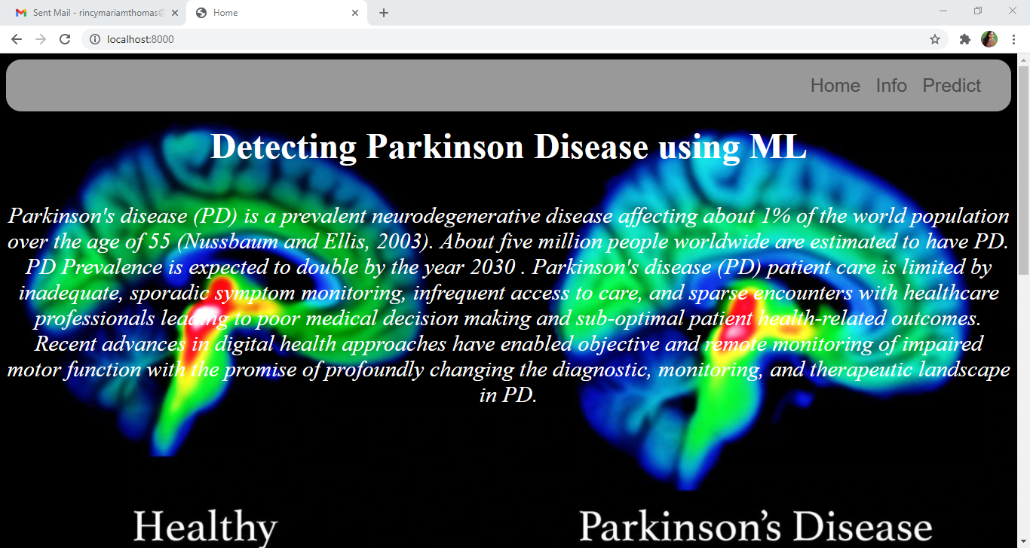

Now when you click on info button from the top right corner you will be redirected to info.html

Let's look at how our info.html file looks like:

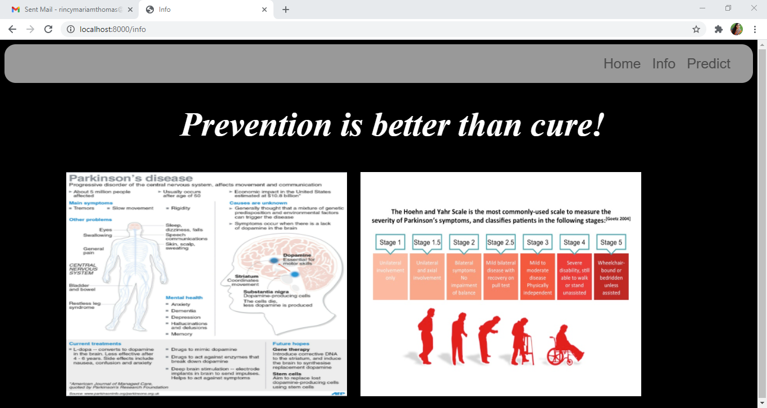

Now when you click on predict button from the top right corner you will be redirected to index6.html

Let's look at how our index6.html file looks like:

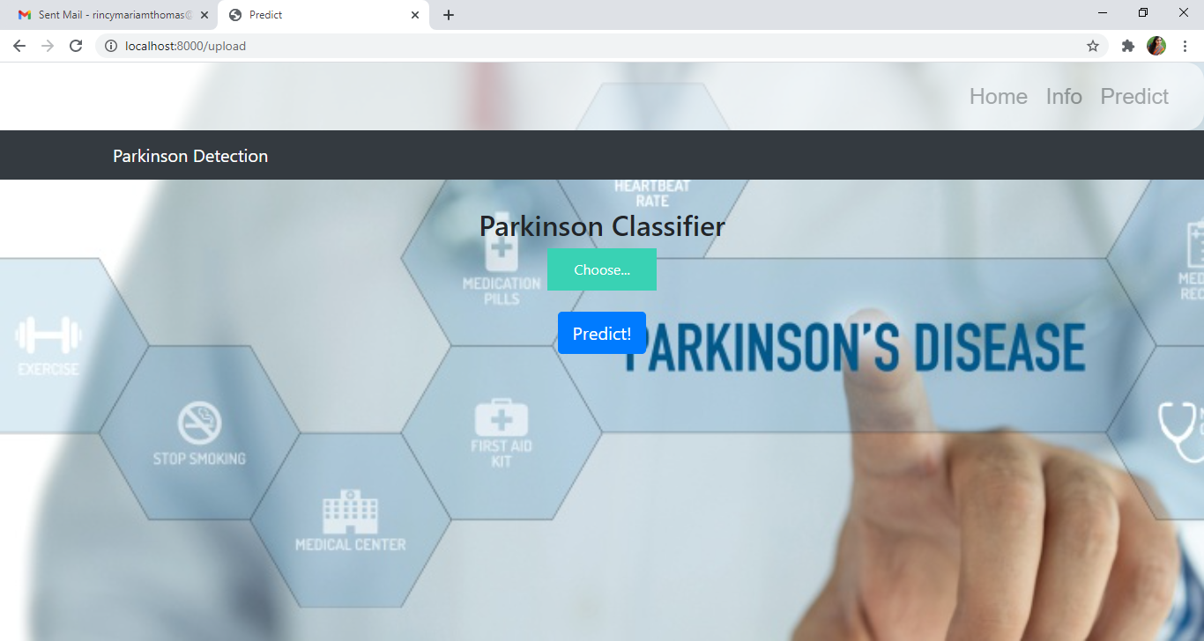

Now from this page give the input image and see the predicted output on the UI

### Build Python Code

**Import the libraries**

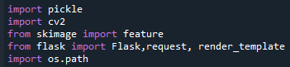

Importing the flask module in the project is mandatory. Flask constructor takes the name of the current module (__name__) as argument.



**Render HTML Page:**

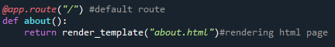

Here, declared constructor is used to route to the HTML page created earlier.

In the above example, ‘/’ URL is bound with about.html function. Hence, when the home page of the web server is opened in browser, the html page is rendered.

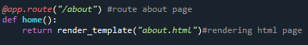

Here, **“about.html”**is rendered when home button is clicked on the UI.

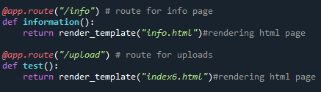

Similarly, **info.html** and **index6.html** are rendered when info and predict buttons are clicked on UI.

Retrieve the Values from UI

Whenever you give the inputs from the html page, the values can be retrieved using POST Method.

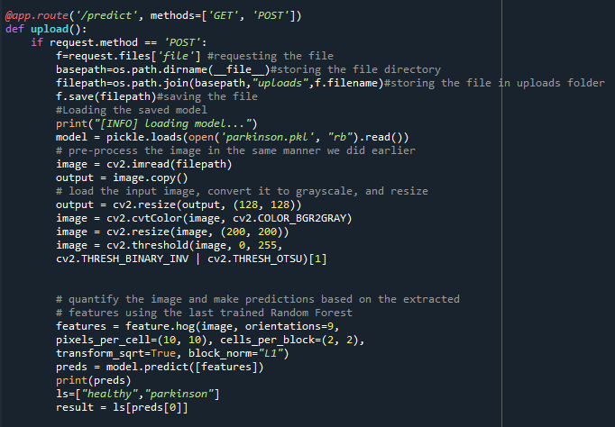

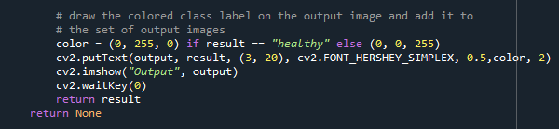

Here we are routing our app to upload() function. This function retrieves all the values from the HTML page using Post request. We are requesting to upload image using the request function.

We take the input from the user, and preprocess the image(convert to gray scale, resize, threshold)).It is necessary to preprocess the data so as give it to the model to predict the output. Once the output is predicted, result is shown on opencv window and html page.

**Main Function:**

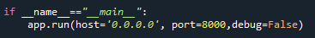

### Run The App

**Open anaconda prompt from the start menu.**

* Navigate to the folder where your app.py resides.
* Now type**“python app.py”**command.
* It will show the local host where your app is running (on http://localhost:8000/)
* Copy that localhost URL and open that URL in the browser. It navigates to view the web page.
* Click on the **predict button** from the top right corner.



Click on choose and select the image and click on the **“Predict!”** button

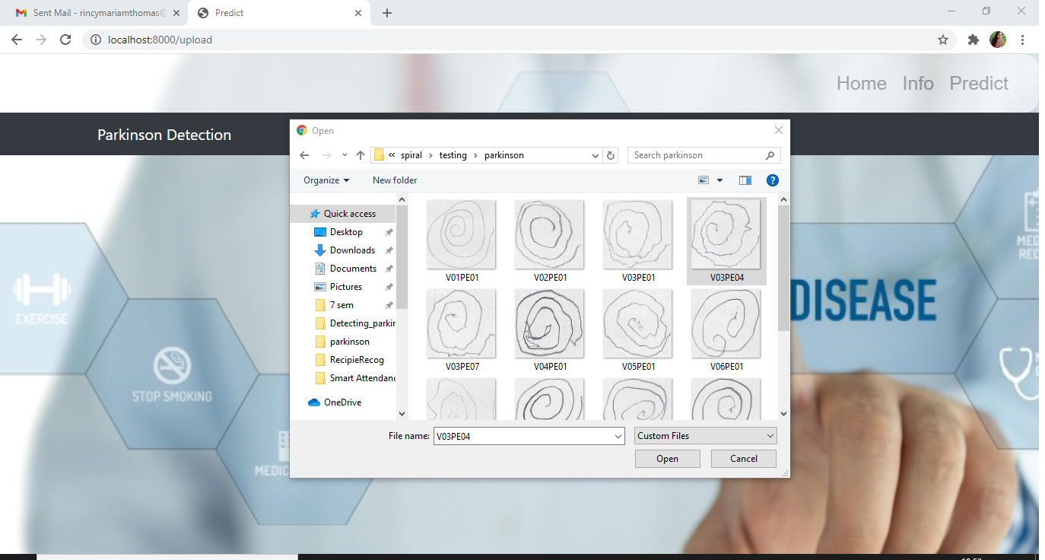

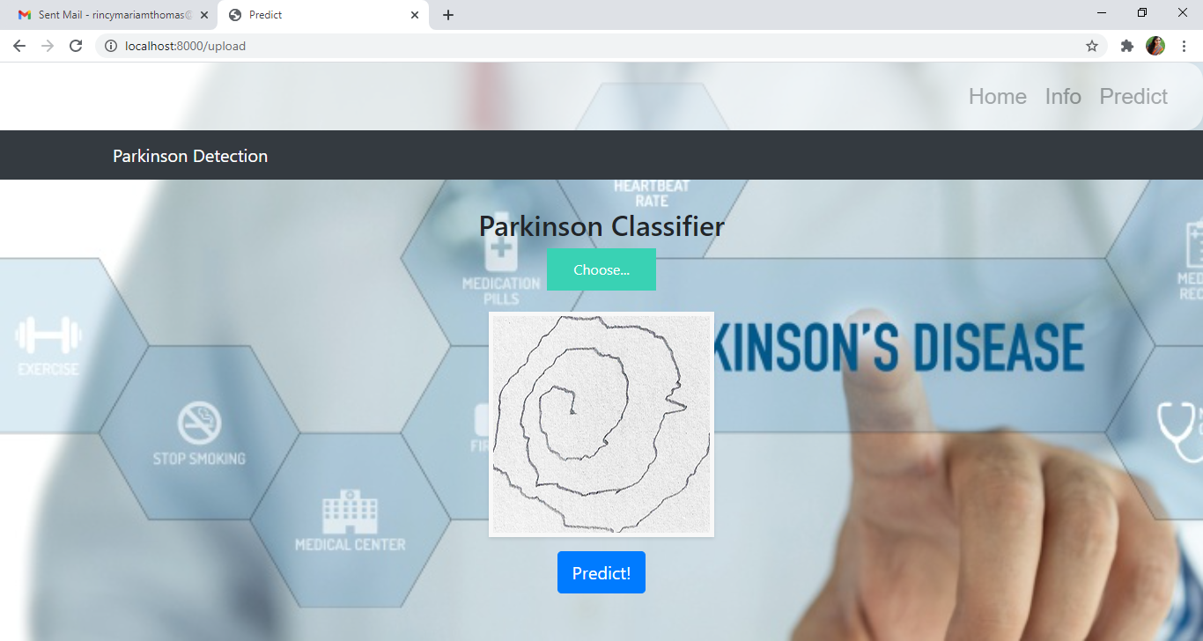

Finally, the output is displayed on **predict.html**

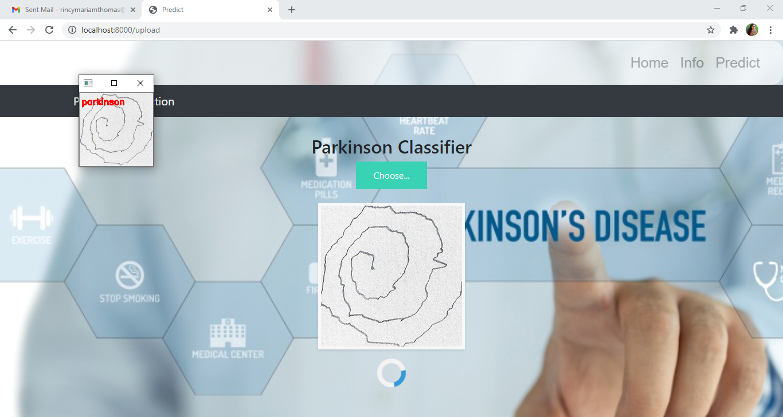

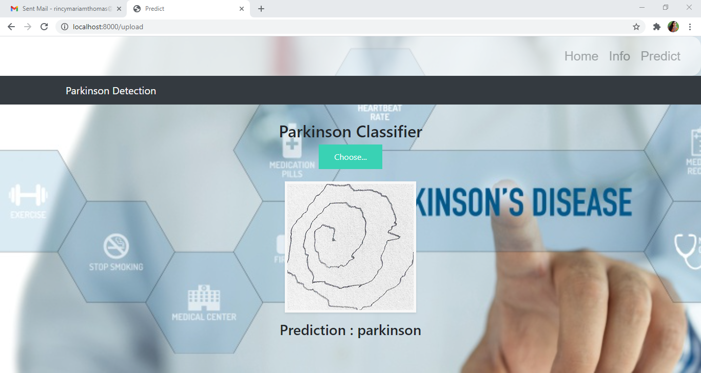

**Train The Model On IBM**

In this milestone, you will learn how to build a Machine Learning  Model and deploy it on the IBM Cloud.

**Register For IBM Cloud**

**IBM Account:**

* Please click [here](https://www.ibm.com/academic/home) to register for IBM
* Please click [here](https://cloud.ibm.com/login)to log in to IBM Account

**Watch the below video to register and login into your IBM account**

<https://youtu.be/x6i43M7BAqE>

**Train Model On IBM Watson**

**Please watch the below video to train the model on IBM  and integrate it with the flask Application**

<https://youtu.be/BzouqMGJ41k>

**Ideation Phase**

In this milestone you are expected to get started with the Ideation process.

**Literature Survey On The Selected Project & Information Gathering**

In this activity you are expected to gather/collect the relevant information on project usecase, refer the existing solutions, technical papers, research publications etc.

**Prepare Empathy Map**

In this activity you are expected to prepare the empathy map canvas to capture the user Pains & Gains, Prepare list of problem statements.

**Ideation**

In this activity you are expected to list the ideas (at least 4 per each team member) by organizing the brainstorming session and prioritize the top 3 ideas based on the feasibility & importance.

**Project Design Phase – I**

From this milestone you will be starting the project design phase. You are expected to cover the activities given.

**Proposed Solution**

In this activity you are expected to prepare the proposed solution document, which includes the novelty, feasibility of idea, business model, social impact, scalability of solution, etc.

**Problem Solution Fit**

In this activity you are expected to prepare problem - solution fit document and submit for review.

**Solution Architecture**

In this activity you are expected to prepare solution architecture document and submit for review.

**Project Design Phase -II**

From this milestone you will be continue working on the project design phase. You are expected to cover the activities given.

**Customer Journey**

Prepare the customer journey maps to understand the user interactions & experiences with the application (entry to exit).

**Functional Requirement**

In this activity you are expected to prepare the functional requirement document.

**Data Flow Diagrams**

In this activity you are expected to prepare the data flow diagrams and submit for review.

**Technology Architecture**

In this activity you are expected to draw the technology architecture diagram.

**Project Planning Phase**

In this milestone you are expected to prepare milestones & tasks, sprint schedules.

**Prepare Milestone & Activity List**

In this activity you are expected to prepare the milestones & activity list of the project.

**Sprint Delivery Plan**

In this activity you are expected to prepare the sprint delivery plan.

**Project Development Phase**

In this milestone you will start the project development and expected to perform the coding & solutioning, acceptance testing, performance testing based as per the sprint and submit them.

**Project Development - Delivery Of Sprint-1**

In this activity you are expected to develop & submit the developed code by testing it.

**Project Development - Delivery Of Sprint-2**

In this activity you are expected to develop & submit the developed code by testing it.

**Project Development - Delivery Of Sprint-3**

In this activity you are expected to develop & submit the developed code by testing it.

**Project Development - Delivery Of Sprint-4**

In this activity you are expected to develop & submit the developed code by testing it.